Philip Dumaresq: Networking: 420-A32

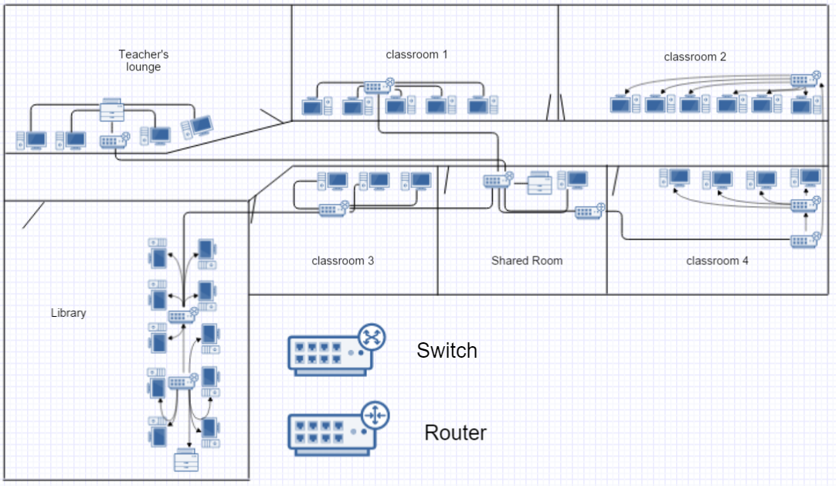

64 feet

88 feet

The network I made requires switches and one router located in the shared room.

There is one switch per room except the library and the 4th classroom where there’s 2.

All of the switches have 8 ports and the router has 4.

All of the switches have at least one port free to expand the network if desirable.

Both switches connected to the router have multiple other switches connected.

The network is composed of 33 computers and 3 printers.

Based on the requirements of having each computer 4 feet apart, my building is 88ft long and 64ft wide.

17 4ft twisted pair wires

12 8ft twisted pair wires

6 12ft twisted pair wires

8 20ft fibre optic wires

The fibre optic cables connect all of the switches and the routers. All of the backbone cables.